Homework 4

**Due on Thursday, June 7**

Q1. Suppose Boeing and Airbus are deciding whether to invest in R&D to improve the quality of their

medium-capacity planes. Given the following payoff matrix in millions of dollars, what is the

Nash equilibrium of the game?

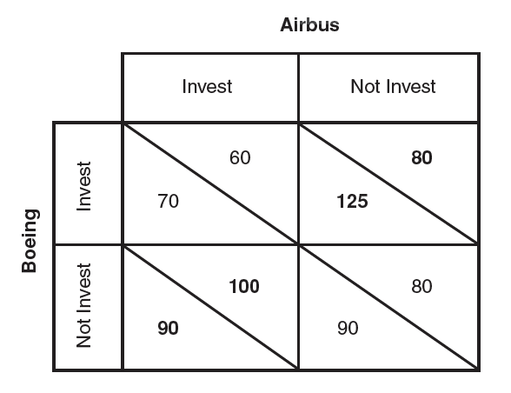

1. Suppose the governments of Europe seek to expand Airbus’ international market share by providing the European aircraft producer with a subsidy of $40 million for R&D. Redraw the payoff matrix and find the Nash equilibrium. Is the subsidy successful in increasing European welfare? Explain.
2. Suppose the United States government decides to support Boeing with a matching subsidy. Redraw the payoff matrix and find the Nash equilibrium. How do these subsidies affect welfare in the United States and Europe?